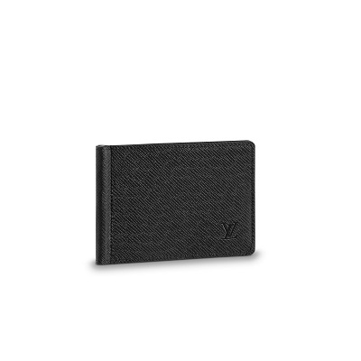

Pince Wallet Taiga Leather

PRODUCT DETAILS

**- 4.3 x 3.3 inches**

**- Damier Graphite coated canvas**

**- Cowhide -leather lining**

**- Silver-color hardware**

**- 4 CC slots**

**- 2 flat pockets**